N.Ananda BharathiSecond yearB.Tech CSBSRamco Institute Of TechnologyRajapalaiyam

(Date)

Dr. L. Ganesan sirRamco Institute Of TechnologyRajapalaiyam

Subject: Completion Report of Technical Projects in IoT

Respected sir

I am writing to submit the completion report of technical projects undertaken as part of my second-year B.Tech CSBS curriculum. As a student deeply interested in the field of Internet of Things (IoT), I have successfully completed a series of projects aimed at exploring various aspects of IoT technology. The projects were conducted under the guidance of our esteemed faculty members and have provided me with valuable hands-on experience and practical skills in the realm of IoT.

MINI PROJECTS

* Using Blynk App to Interface LED:

Objective: To control an LED remotely via a smartphone using the Blynk app.

Description: This project involved configuring a microcontroller to communicate with the Blynk server and respond to commands sent from the Blynk mobile application. The LED could be toggled on or off remotely using the app interface.

* Servo Motor Control Using IMT Tool:

Objective: To control a servo motor wirelessly using a mobile application.

Description: Utilizing IoT tools, I implemented a system where the position of a servo motor could be adjusted through commands sent from a mobile app. This project showcased the integration of hardware and software to achieve remote control functionality.

* GPS Using Raspberry Pi 3:

Objective: To retrieve and process GPS data using a Raspberry Pi 3.

Description: With the Raspberry Pi 3 and a GPS module, I developed a system capable of acquiring and interpreting GPS data such as latitude, longitude, and altitude. This project emphasized the utilization of Raspberry Pi for IoT applications.

* Diagonal Sensor Interface:

Objective: To interface an analog sensor (type unspecified) with a microcontroller.

Description: This project focused on connecting an analog sensor to a microcontroller and reading sensor values for further processing. While the specific sensor type is not mentioned, the project highlighted the principles of sensor interfacing.

* Gas Sensor Interface with Raspberry Pi 4:

Objective: To detect and monitor gas levels using a Raspberry Pi 4.

Description: I interfaced a gas sensor module with the Raspberry Pi 4 GPIO pins and developed software to monitor environmental gas levels. This project explored the application of IoT in environmental sensing.

* ESP32-S3 T - Display:

a) Interfacing Temp and Humidity:

Objective: To measure and display temperature and humidity readings using ESP32-S3.

Description: Using ESP32-S3 and a temperature/humidity sensor, I developed a system to acquire sensor data and display it on a connected OLED or LCD display.

b) Interfacing LED Using Blynk App:

Objective: To control an LED connected to ESP32-S3 via the Blynk app.

Description: This project involved configuring ESP32-S3 to communicate with the Blynk server, allowing remote control of the LED using the Blynk mobile application.

c) Interface Using Blynk App to Interface Temp and Humidity:

Objective: To monitor temperature and humidity remotely using the Blynk app.

Description: By integrating a temperature/humidity sensor with ESP32-S3, I enabled real-time monitoring of environmental conditions through the Blynk mobile application.

These projects have not only enhanced my technical skills but have also instilled in me a deeper understanding of IoT principles and their practical applications. I am grateful for the opportunity to work on these projects and for the guidance and support provided by the faculty.

Thank you for considering my submission. I am confident that these projects will contribute to the academic and technical excellence of our college.

REAL TIME PRODUCT BASED PROJECTS

AUTOMATIC DOOR LOCKING SYSTEM:

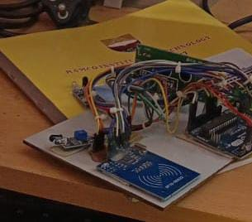

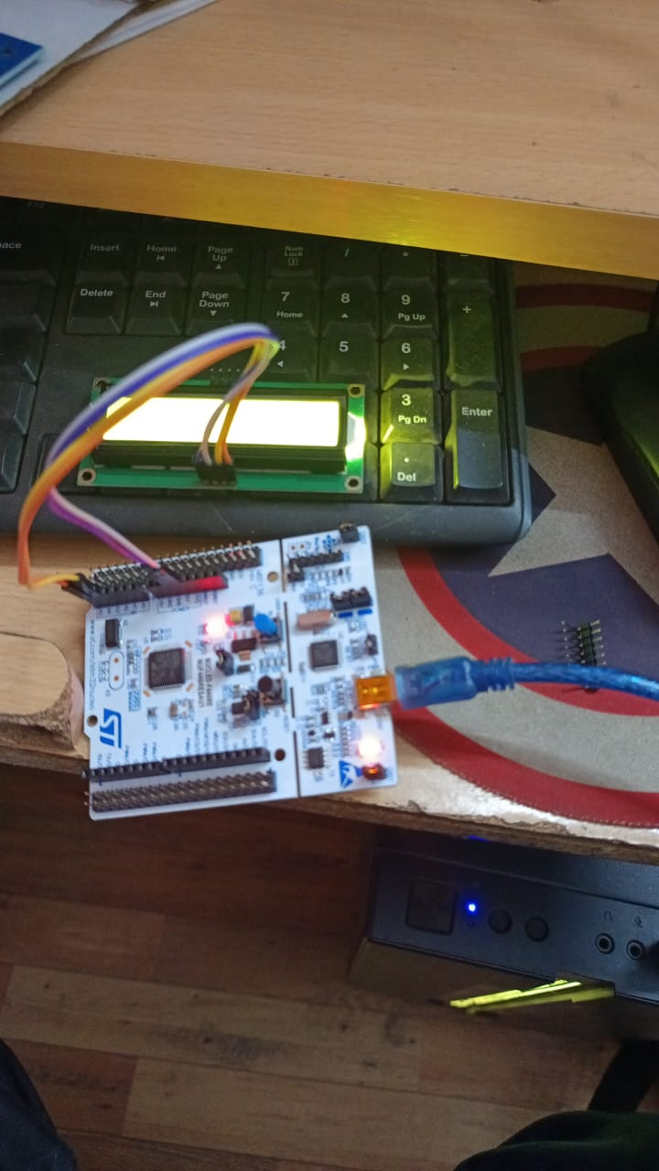

**Objective**

The objective of this project is to design and implement an **Automatic Door Locking System** using an STM32 microcontroller. The system will provide secure, automated access control by locking and unlocking a door based on user authentication methods such as password entry, RFID card scanning, or wireless commands via Bluetooth/Wi-Fi. The system aims to improve security, convenience, and accessibility for users in residential or commercial environments.

**Description**

The Automatic Door Locking System is a microcontroller-based project designed using the STM32 platform. The system will control the locking mechanism (servo motor or solenoid) by processing inputs from various authentication methods. These may include:

* **Keypad Input**: Users can enter a predefined password using a matrix keypad to unlock the door.
* **RFID Authentication**: The system will read RFID cards via an RFID module (e.g., MFRC522). If the card matches a registered ID, the door unlocks.
* **Bluetooth/Wi-Fi Control**: Users can control the locking system remotely using a mobile app via Bluetooth or Wi-Fi, sending lock/unlock commands to the STM32.
* **Display Feedback**: An optional LCD display can provide real-time status messages such as "Access Granted", "Access Denied", or "System Locked".
* **Buzzer**: The system will also include an auditory feedback system using a buzzer to signal successful or unsuccessful attempts at unlocking the door.
* **Security Features**: The system will include features like secure password storage, timeout mechanisms to prevent brute force attacks, and logging of failed access attempts.

EEMO ROBO :

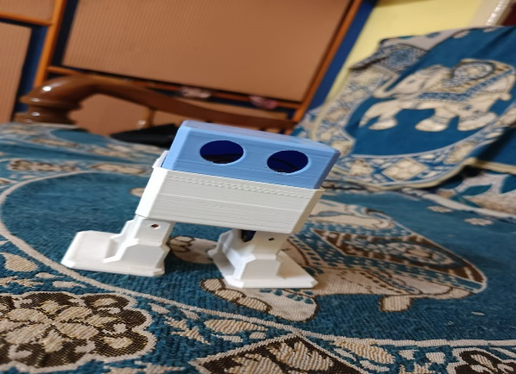

**Objective:**

The objective of this project is to design and build an **Eemo Robo** (a small-scale, gesture-controlled robot) using Arduino. The robot will be capable of following user commands based on hand gestures or sensor inputs and will navigate its environment autonomously or semi-autonomously. The goal is to explore robotics concepts such as motor control, sensor integration, and gesture recognition, making it an ideal project for learning Arduino programming, robotics, and automation.

**Description:**

The **Eemo Robo** is a compact, Arduino-based robot that can respond to hand gestures, allowing for intuitive control and movement. The project utilizes Arduino as the main controller to interface with various sensors, motors, and communication modules to bring the robot to life. The core features of the Eemo Robo include:

* **Gesture Control**: The robot will be equipped with sensors such as an **Accelerometer/Gyroscope (e.g., MPU6050)** to detect hand gestures, which are processed to control the robot's movements like moving forward, backward, turning, and stopping.
* **Motor Control**: The robot will use **DC motors or servo motors** for movement, which will be driven using an **H-Bridge motor driver** (e.g., L298N). The Arduino will control the speed and direction of the motors based on input from the gesture sensors.
* **Ultrasonic Sensors**: To prevent collisions, the robot will use **ultrasonic sensors (e.g., HC-SR04)** to detect obstacles in its path. If an object is detected within a certain range, the robot can stop or change direction automatically.
* **Bluetooth Control (Optional)**: The robot can be paired with a mobile app or controller via **Bluetooth** (e.g., HC-05) to allow remote control using a smartphone.
* **Line Follower (Optional)**: For additional functionality, the robot can also be equipped with **IR sensors** to enable line-following capabilities, making it a multi-functional educational robot.

FACE RECOGNITION SYSTEM BY INTERFACEING IN LED PANEL USING ESP32 CAM:

Objective:

The objective of this project is to design and implement a **Face Recognition System** using the **ESP32-CAM** module. The system will be capable of capturing images, detecting faces, and recognizing them based on a pre-trained database. It aims to provide a low-cost, efficient solution for security and access control applications, leveraging the ESP32-CAM’s onboard camera and processing capabilities for face detection and recognition.

Description:

Pre trained data of my college faculty members picture was given into the database, when the faculty member enters the Department it will automatically detect the their face and showcase their name and other information to the corresponding head of the department personal monitor. Also it has been used for taking the students addentence system

Working feature:

**Face Detection and Recognition**: The ESP32-CAM module, powered by an **OV2640 camera**, will be used to capture images. The onboard processing unit can perform **face detection** using the **OpenCV library** or **ESP-WHO**, a face detection and recognition framework designed specifically for ESP32.

**Pre-Trained Face Database**: The system will store facial data (images) of authorized users in memory. During operation, it will compare captured faces to the database and identify individuals based on predefined parameters like facial features.

**Real-Time Image Capture**: The camera will continuously capture frames and send them to the ESP32’s processor for analysis. It will detect faces in real time and execute the recognition algorithm if a face is detected.

**Wi-Fi Connectivity**: The ESP32-CAM will be connected to a Wi-Fi network, enabling remote monitoring and control. Through a web interface or mobile app, users can view the camera feed, manage the face database, and monitor recognized faces.

**Access Control (Optional)**: The system can be integrated with a relay or solenoid lock mechanism to automatically unlock a door if a recognized face is detected. This makes it ideal for access control systems in homes, offices, or secure areas.

**Notifications (Optional)**: The ESP32-CAM can be programmed to send notifications (e.g., via **email** or **push notifications**) when an unrecognized face is detected, enhancing the system’s security features.

DOG ROBO USING ARDUINO UN0:

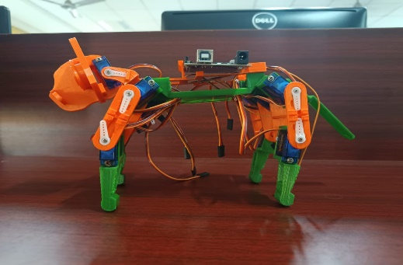

Objective:

The objective of this project is to design and build a **Dog Robot** using **12 servo motors** controlled by an **Arduino** microcontroller. The robot will mimic the basic movements of a quadruped (four-legged) animal, such as walking, turning, sitting, and standing. The project aims to explore the principles of robotics, servo control, and Arduino programming while creating a fun and interactive robot capable of performing dog-like behaviors.

Description:

The **Dog Robot** project is a quadrupedal robot built using **12 servo motors** to replicate the motion of a dog’s legs and body. The robot is powered and controlled by an Arduino board, which coordinates the movement of the servos to achieve realistic walking and other motions. This project is an excellent way to dive into robotics, mechatronics, and coding, allowing for creativity in both movement patterns and behaviors.

The robot can simulate pet-like behaviors, making it a fun project for hobbyists who enjoy creating robotic animals. It is mainly used for the entertainment purpose. Modifications could involve adding sensors like cameras or machine learning capabilities for advanced decision-making and mobility tasks.

SMART THERMOSTAT :

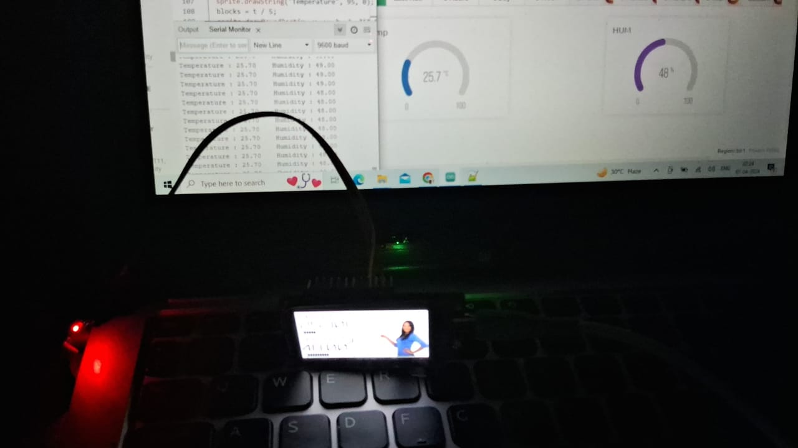

**Objective**

The objective of this project is to design and implement a **Smart Thermostat** system using an **ESP32-T Display**, a **temperature sensor**, and a **relay module** to control heating and cooling systems. The thermostat will automatically regulate the temperature in a room by turning HVAC systems on or off based on the user’s preset temperature settings. This project aims to provide an energy-efficient, user-friendly thermostat system that can be controlled locally or remotely via a mobile app or web interface.

**Description**

The Smart Thermostat project is an intelligent temperature regulation system designed to control heating, ventilation, and air conditioning (HVAC) systems automatically. By integrating a temperature sensor (such as the DHT11/DHT22 or DS18B20) with an Arduino or ESP32 microcontroller, the thermostat continuously monitors the ambient temperature and compares it to a user-defined target temperature. Based on this comparison, the system activates or deactivates a relay module connected to heating or cooling devices to maintain the desired temperature range.

Key features:

**Temperature Sensing**: The thermostat will use a **temperature sensor** like **DHT11/DHT22** or **DS18B20** to measure the room temperature in real-time.

**Automatic HVAC Control**: A **relay module** connected to the microcontroller will control the HVAC system by turning it on or off based on the room’s temperature compared to the preset temperature set by the user.

**User Interface for Setting Target Temperature**: The user can set a target temperature via a **physical interface** (such as buttons and an LCD display) or a **remote interface** (such as a web or mobile app if using ESP32 or Arduino with Wi-Fi).

**Energy Efficiency**: By ensuring the heating or cooling system operates only when necessary, the smart thermostat optimizes energy usage, reducing power consumption and lowering electricity bills.

**Remote Control and Monitoring**: If implemented with an **ESP32** (or connected to a Wi-Fi module like ESP8266), the system can be monitored and controlled remotely through a mobile app or web interface. Users can adjust the target temperature and view real-time temperature data from anywhere.

**Data Logging (Optional)**: The system can log temperature readings and HVAC activity, allowing users to monitor trends and optimize the system’s performance over time.

**Safety Features**: The system can be programmed to send alerts or take corrective actions if the temperature goes beyond a safe range, preventing overheating or freezing in critical environments.



SPIDER ROBO USING ARDUINO NANO EXPANSION BOARD:

**Objective**

The objective of this project is to design and build a **Spider Robot** using an **Arduino** microcontroller and multiple **servo motors**. The robot will mimic the movement of a real spider with coordinated leg movements for walking, turning, and climbing. The primary goal is to explore robotics and walking algorithms while developing skills in servo motor control, Arduino programming, and mechanical design. The Spider Robot can be used for educational purposes and entertainment.

**Description**

The **Spider Robot** project involves creating a multi-legged robot (typically 8 legs, like a real spider) that can move autonomously or be remotely controlled. It uses **servo motors** to control each leg, allowing it to perform realistic walking movements. The robot can navigate uneven terrain and potentially interact with its environment using sensors.

The system is powered by an **Arduino** microcontroller, which is programmed to control the leg movements through the precise control of the servos. By using a combination of forward, backward, and rotational movements, the robot can walk in any direction, turn, or even climb small obstacles.

AUTOMATIC GATE LOCKING AND UNLOCKING SYSTEM:

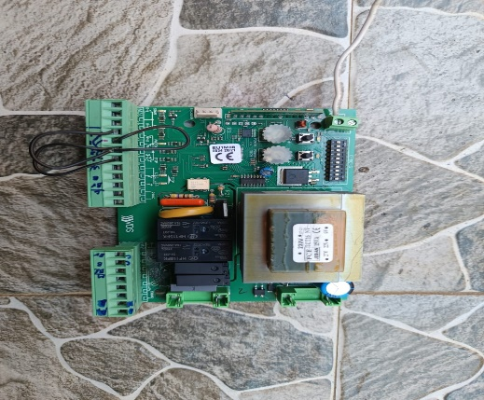

**Objective**

The objective of this project is to design and implement an **Automatic Gate Locking and Unlocking System** BY building my own PCB BOARD with various sensors (such as **RFID**, **keypad**, or **Bluetooth**) and High powered Transformer. The system aims to automatically secure gates by locking and unlocking them based on authorized access, providing enhanced security, ease of use, and automation. This project is ideal for applications in homes, offices, or restricted areas where automated access control is needed.

**Description**

The **Automatic Gate Locking and Unlocking System** is a smart security solution that uses a combination of **microcontrollers**, **sensors**, and **actuators** to automate the process of locking and unlocking a gate. The system ensures that only authorized personnel can access the premises, and it can be controlled via **RFID**, **keypad**, **Bluetooth**, or a **mobile app**. When the system detects a valid input (such as a correct Bluetooth signal), it automatically triggers the motor or lock to open the gate. After a set period, the gate can be re-locked automatically to maintain security

**Automated Gate Control**: The system automatically locks or unlocks a gate based on an authorized signal, such as RFID or a Bluetooth connection from a smartphone.

**Access Authorization**: Multiple methods of access control can be implemented, including:

* **RFID**: Users scan an RFID card or tag to unlock the gate.
* **Keypad**: A numeric keypad can be used to input a passcode for unlocking.
* **Bluetooth**: Users can unlock the gate via a Bluetooth-enabled smartphone or app.
* **Wi-Fi (Optional)**: With a Wi-Fi-enabled module like **ESP32**, the system can be controlled remotely through a mobile app or web interface.

**Locking Mechanism**: The locking and unlocking action is performed by either a **servo motor**, a **solenoid lock**, or an **electromagnetic lock**. The choice of actuator depends on the type of gate and the security level required.

**Automatic Re-Locking**: The system can be configured to automatically lock the gate after a set period once it has been unlocked, ensuring security if the user forgets to lock it manually.

**Optional Sensors**: Sensors like **ultrasonic** or **IR sensors** can be added to detect whether the gate is fully closed or open, providing additional safety and automation.

**Remote Monitoring and Control (Optional)**: If a Wi-Fi-enabled microcontroller like **ESP32** is used, users can monitor and control the gate remotely through a smartphone app or web interface, receiving notifications if the gate is left unlocked or accessed.

**Safety Features**: The system can include safety mechanisms, such as manual override buttons or emergency unlock options in case of power failure.

A SMART AUTONOMOUS AUTOMATED GARBAGE COLLECTOR SYSTEM FOR THE SMART CITIES:

Objective:

The Smart Autonomous Automated Garbage Collector System uses AI, IoT, and robotics to manage waste efficiently in smart cities.  
It autonomously detects, collects, and disposes of garbage using sensors, GPS, and machine learning.  
Real-time data analytics enable optimized routes and timely pickups, reducing operational costs.  
The system is solar-powered and energy-efficient, aligning with green computing practices.  
It minimizes the need for human labor and enhances environmental cleanliness.  
Overall, it promotes eco-friendly, healthier, and smarter urban living.

Description:

The Smart Autonomous Automated Garbage Collector System is an innovative solution that leverages advanced technologies for efficient waste management in smart cities. It features AI-driven autonomous robots capable of navigating urban areas, identifying waste collection points, and collecting garbage without human assistance. Integrated IoT-enabled smart sensors monitor the fill levels of bins in real-time, enabling dynamic scheduling and preventing overflow. Machine learning algorithms enhance route optimization and decision-making over time, making the system smarter and more resource-efficient. Powered by solar panels and designed with energy-efficient components, the system reduces operational costs and environmental impact. Real-time data supports dynamic route optimization, ensuring garbage collection vehicles take the most efficient paths. Additionally, a centralized control platform allows for remote monitoring, system diagnostics, and route performance tracking. Overall, the system promotes sustainable waste management by minimizing reliance on manual labor and traditional fuel-powered trucks, aligning with smart city goals for reduced emissions and improved environmental health.

Block Diagram:

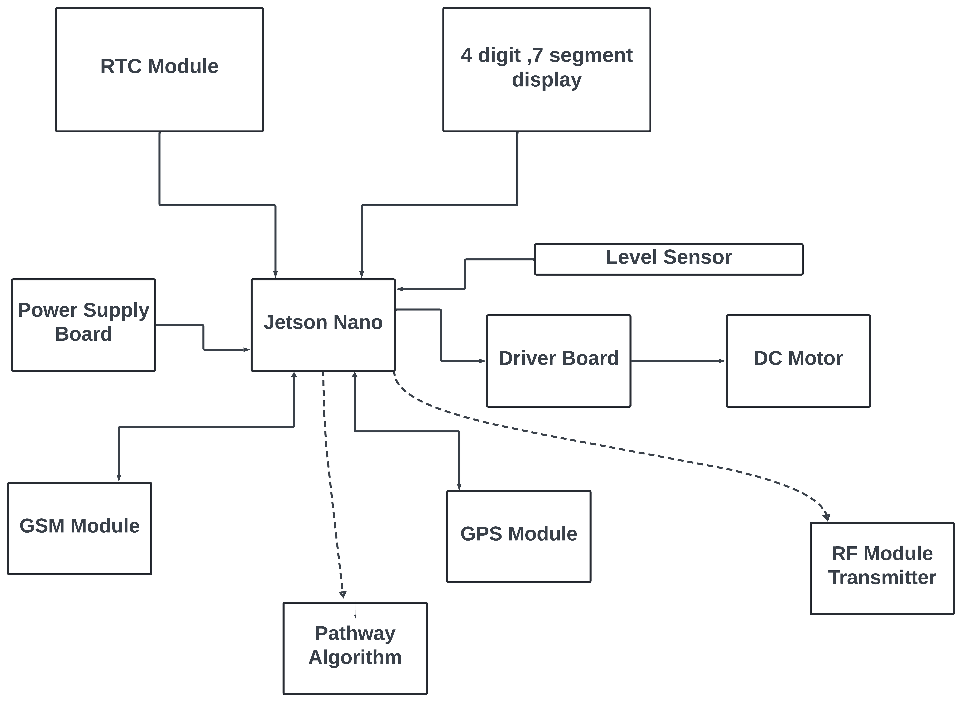

TRANSMITER

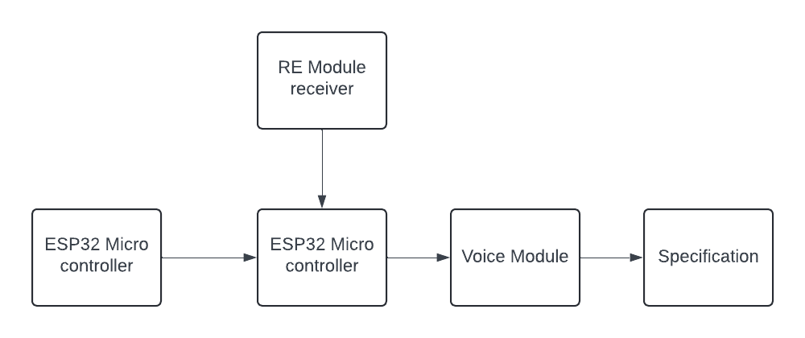

RECIEVER

PLANT DISEASE ANALYSIS USING MULTIFUNCTIONAL ROVER:

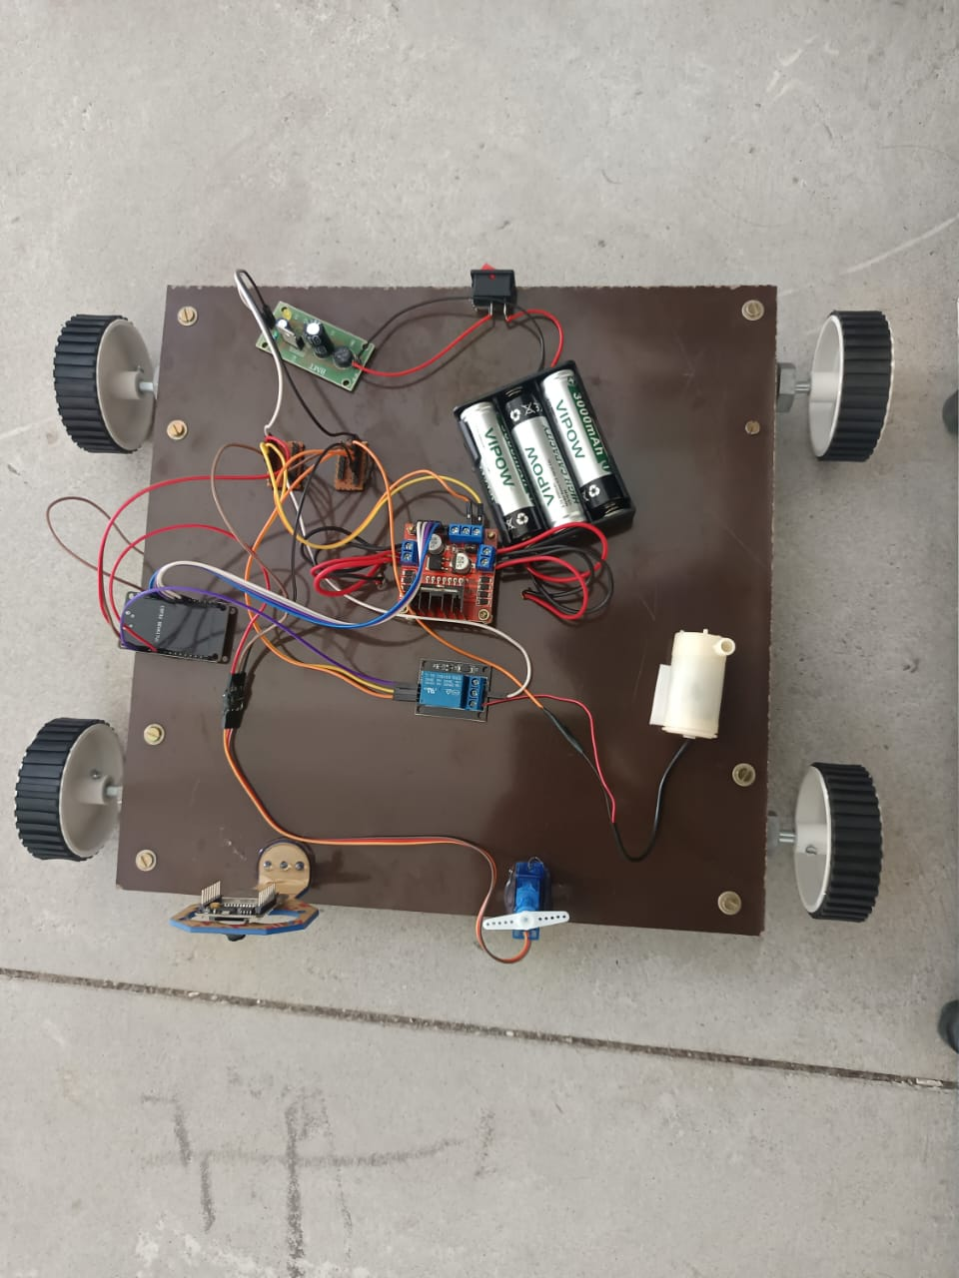

CURRENT STATUS OF THIS PROJECT

Objective:

The increasing threat of plant diseases to global food security necessitates efficient, precise, and scalable methods for disease monitoring and management. This study explores the application of a multifunctional rover for plant disease analysis, integrating advanced sensing technologies, machine learning algorithms, and autonomous mobility. The rover is designed to navigate agricultural fields, autonomously detecting and diagnosing plant diseases by utilizing a combination of visual, thermal, and spectral sensors. These sensors provide real-time data on plant health indicators, including changes in leaf color, temperature anomalies, and other stress markers. By processing this data through an artificial intelligence (AI)-driven analysis system, the rover is capable of identifying early signs of disease outbreaks, even in the most remote or large-scale agricultural environments. Incorporating advanced image processing and pattern recognition algorithms, the rover enables accurate differentiation between disease types, including bacterial, fungal, and viral infections. Moreover, the rover is equipped with GPS and mapping technologies, allowing for the creation of detailed, geo-referenced disease maps that guide precise interventions, such as targeted pesticide application. The integration of autonomous navigation ensures that the rover can cover extensive areas with minimal human intervention, enhancing the efficiency of disease monitoring. Additionally, the multifunctional design includes capabilities for soil analysis, water stress detection, and pest surveillance, making it a versatile tool for integrated pest management (IPM) strategies

Description:

Block diagram:

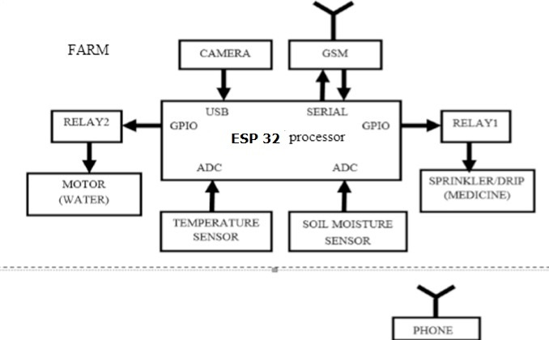

The plant disease detection system is composed of several integrated components designed to work together for efficient monitoring and diagnosis in agricultural fields. At the core is the **ESP32 Rover Unit**, which controls the rover's hardware, including motors, sensors, and the camera, while also managing wireless data transmission. The system includes various **environmental sensors** to collect temperature, humidity, and soil moisture data that support disease analysis. A **camera module** (such as the ESP32-CAM) captures high-resolution images of plant leaves, which are then processed either locally using **TensorFlow Lite** or sent to a **cloud server** for disease classification. A **mobile app or web dashboard** displays disease detection results, rover status, and environmental data to the user.

The system is implemented through multiple components. The first focuses on autonomous navigation using motors, ultrasonic sensors for obstacle avoidance, and a GPS module for route planning. The second handles image capture and preprocessing, applying techniques like noise removal, color normalization, and segmentation to prepare images for analysis. The third involves disease detection using machine learning, where a CNN model is either run on the ESP32 or in the cloud, classifying plant diseases based on image features. The fourth collects environmental data via sensors and sends it to the cloud for contextual analysis. The fifth enables real-time communication using Wi-Fi and MQTT or HTTP protocols to transmit sensor and image data to the cloud and receive feedback. The sixth handles cloud processing, running heavier machine learning models and storing data, while the seventh provides a user interface through a mobile app or web dashboard developed using platforms like React Native or Flutter.

The **data flow** begins with the ESP32 capturing images and sensor readings, transmitting them to the cloud for processing and classification, and displaying results and recommendations via the mobile app. The **implementation flowchart** includes powering up the rover, initializing systems, navigating fields with obstacle avoidance, capturing and analyzing images, sending data, and notifying the farmer with disease alerts and treatment suggestions. This integrated system provides a powerful, real-time solution for plant disease detection and precision agriculture.

We are able to watch the plants health and the monitoring status and machines working status will visualize by using powebi dashboard.

INNOVATIVE SENSOR TECHNOLOGY FOR MAPPING MARINE FISH POPULATION:

Objective:

This proposal presents a revolutionary method of locating places with the highest numbers of

fish in the sea using cutting-edge sensor technology, thereby identifying hotspots for marine

biodiversity. The objective of our project is to create and implement a range of sensors that

can identify different environmental factors including water flow, temperature, and salinity.

Additionally, we want to use acoustic monitoring methods to record fish activity. We will be

able to produce an extensive map of fish distribution patterns in various marine habitats by

merging these data sources. In addition to improving our knowledge of fish habitats and

ecological requirements, this research will help guide conservation and sustainable fishing

methods. In the end, our research will help preserve marine biodiversity and ensure that

ocean resources are managed efficiently.

Descrpiton :

For the purpose of marine conservation and sustainable fishing methods, an understanding of fish dispersion is essential. The accuracy and scope of traditional methods of measuring fish populations are frequently constrained. This proposal offers a state-of-the-art method for locating locations in the ocean with the highest populations of fish using hardware sensors. Our goal is to gather data on fish behavior and water conditions in real time by implementing an array of environmental and auditory sensors. With the use of this technology, we will be able to investigate the variables that affect fish habitats, which will yield insightful information for ecological studies and resource management. Finding marine biodiversity hotspots will ultimately help decision-makers in marine conservation initiatives.

Multi-Sensor Network: Deployment of environmental sensors (temperature,

salinity, turbidity) and acoustic sensors to gather comprehensive data on marine

conditions and fish presence.

Real-Time Data Collection: Continuous monitoring of aquatic environments to

provide up-to-date information on fish populations and behavior.

Advanced Data Analytics: Utilization of machine learning algorithms to analyze

data patterns and predict fish hotspots based on environmental factors.

User-Friendly Interface: Development of an accessible platform for stakeholders,

including researchers, policymakers, and fishermen, to visualize data and trends.

Scalability: Flexible sensor deployment options that can be adjusted based on

specific research needs or geographic areas of interest.

BLOCK DIAGRAM:

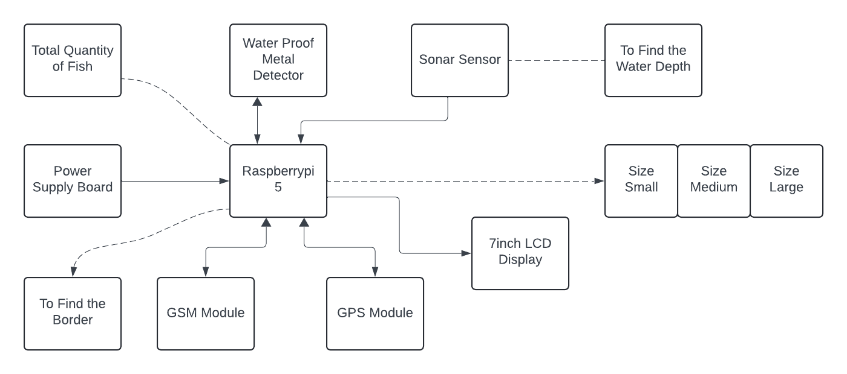

Yours Sincerely,

N. Ananda Bharathi

Second Year B.Tech CSBS